Simpler recycling – communications toolkit |  |  | 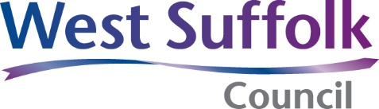
[ Business name ] – Introduction to waste and recycling for new employees
What’s changing?  As of 31 March 2025, all workplaces (businesses, schools, hospitals and so on) with 10 or more full time equivalents (FTE) in England are required to recycle the following waste separately:  - Recyclable: plastic, metal, paper, card.  - Glass: glass bottles and jars.  - Food: all food products including cooked, uncooked and tea bags and coffee grounds.  - Non-recyclable: all other non-hazardous waste.  Following recycling legislation helps reduce our organisation’s environmental impact, reduce our costs, and ensures we are compliant with the regulations. Therefore, we have implemented new waste practices to comply with this, it is important that you understand how to dispose of waste at work in the correct way – just as you would at home.  Failure to separate the materials or clean them properly before disposing could lead to our collection being rejected, and the materials ending up in landfill or incineration alongside additional costs incurred. | What do you need to know?  If you do not know what bin your waste goes in, please refer to our recycling poster on the next page.  Our recycling bins are located:  Food caddies are located:  Our waste is collected on a:  Every: week(s).  If you have any questions or notice any problems with the bins you can speak to: | What you need to do?  Check whether the item you need to dispose of is food waste, recyclable, or non-recyclable.  Break down any multi-material products (for example sandwich packaging and food waste) to ensure as much can be recycled as possible.  Remove any food waste or residue from recyclable materials before disposing in the recycling containers. (Rinse jars, can’s and so on.)  Make sure that the food bin is lined with clear bag.  New bags can be found:  Dispose of the item according to the correct bin (see page below).  If you see something has been put in the incorrect bin, please report it to:
Last updated:
Document owner:
Which bin |  | What can go in? | What cannot go in?
Brown food caddy or wheeled bin | 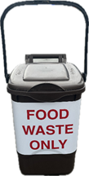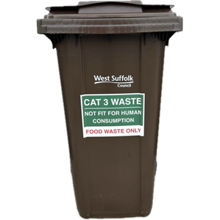 | Food waste - can go in  - Egg shells and vegetable peel  - Meat, fish and bones  - Cooked and uncooked food  - Tea bags and coffee grounds  - Leftovers and moldy food | Food waste - can’t go in  - Non-food waste materials  - Large amounts of paper napkins  - Loose packaging  - Glass  - Liquids
Blue wheeled bin | 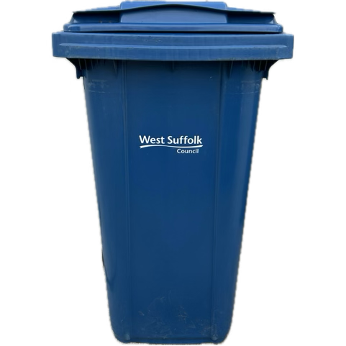 | Dry recycling - can go in  - Items must be clean, dry and loose  - Plastic - bottles, pots, tubs and trays  - Metal - tins, cans, foil and empty aerosols  - Paper - office paper, newspapers, magazines, books, envelopes. | Dry recycling - can’t go in  - Hard plastics for example toys, buckets and boxes  - Plastic films and wrappers (until 2027)  - Glass of any kind  - Food waste  - Tissues and paper towels
Blue wheeled bin for cardboard only | 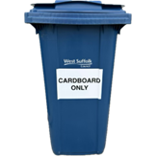 | Cardboard only - can go in  - Items must be flattened  - Corrugated cardboard  - Cardboard boxes  - Brown paper | Cardboard only - can’t go in  - Contaminated cardboard  - Food-stained cardboard such as pizza boxes
Black or green bin with glass sticker | 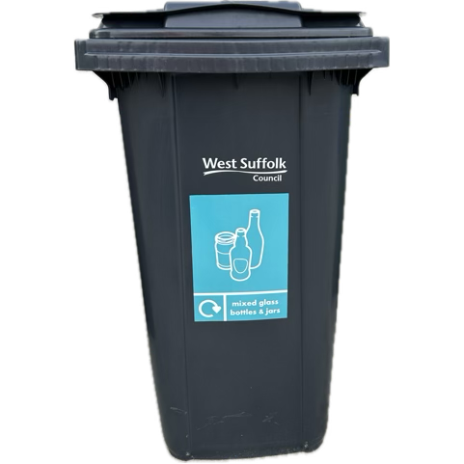 | Glass - can go in  - Glass bottles and jars only  - No other types of glass | Glass - can’t go in  - Broken drinking glasses for example wine glasses  - Pyrex  - Window glass
Green wheelie bin | 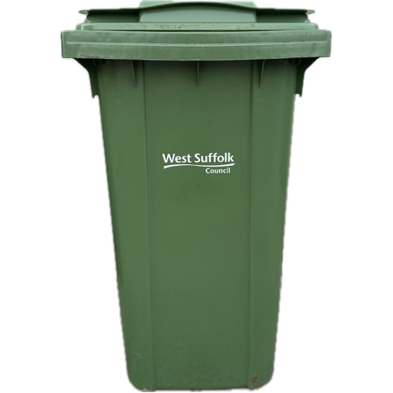 | Non-recyclable waste - can go in  - Plastic film, wrappers and bags  - Polystyrene  - Ceramics and broken drinking glasses  - Highly contaminated items that cannot be cleaned for recycling  - Paper towels and tissues | Non-recyclable waste - can’t go in  - Food waste  - Any recyclable items  - Hazardous waste  - Bricks, rubble or stones  - Liquids and paint  - Electrical items

