Whats On West Suffolk – Event Listings
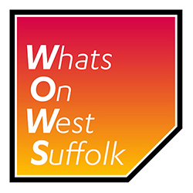
You are welcome to submit your event(s) for listing on www.whatsonwestsuffolk.co.uk

Please complete the appropriate form and return to marketing@whatsonwestsuffolk.co.uk

There are two options available: event listing only, or – if your event is ticketed and you are charging an admission – we can also manage your Box Office for you if you wish, selling tickets to your event both online, by telephone and in person at The Apex for a small charge. As a trusted partner we will then pay out the proceeds to you quickly and efficiently.

Event listing only:
If you just want us to list your event, please fill in and return Event Info Form A – web listing only.

A small charge may apply to list your event; we will contact you on receipt of your submission to advise you of any cost and you can then decide if you wish to proceed. A typical cost for an event listing is £10 per event for charities and £20 per event for non-charities.

Event Listing with Box Office:
If you would also like us to sell tickets to your event, please fill in and return Event Info Form B – with Ticket Sales a minimum of 6 weeks before you want your event to go on sale. Some additional paperwork will be required.

In addition to the event listing fee (as per event listing only, above), a Box Office set up fee of £10 per event is payable in advance. If ticket sales income exceeds £100, this will be refunded and added back into the ticket sales income payable to you.
A ticket sales commission of 12.5% will be payable on each ticket sold, and you will be advised of this prior to any event listing being accepted.

WOWS (which is owned and managed by St Edmundsbury Borough Council) reserves the right to refuse an event listing that we may feel is inappropriate.

